Executive Summary for Consumer Product Safety Analysis

Problem Statement – Slide -1

Summarize the Organizational context and objectives of the project from the below paragraphs.

Background
The Consumer Safety Research Institute (CSRI) is a (fictional) nonprofit organization that conducts independent research on consumer product safety and publishes evidence-based analysis to inform public discourse and policy decisions. Founded in 2012, CSRI specializes in translating complex injury surveillance data into accessible insights that serve consumers, policymakers, safety advocates, and researchers. The organization operates at the intersection of public health and consumer advocacy, filling a critical gap between government data collection and public understanding of product safety risks.
CSRI's work contributes to the broader landscape of consumer protection and public health research. While government agencies like the Consumer Product Safety Commission collect comprehensive injury data through systems like NEISS, there remains a significant need for independent analysis that can identify trends, generate insights, and communicate findings to diverse audiences.
The organization publishes an annual "Product Safety Spotlight" report that examines emerging trends in consumer product injuries, identifies priority areas for public attention, and provides recommendations for consumers, manufacturers, and policymakers. These reports serve multiple audiences including parent advocacy groups, policy researchers, product liability attorneys, insurance industry analysts, and regulatory agencies seeking independent analysis of national injury patterns.
Public discussion of consumer product safety often relies on anecdotal reports, high-profile incidents, or manufacturer marketing claims rather than systematic analysis of national injury data. While comprehensive injury surveillance data exists through the National Electronic Injury Surveillance System (NEISS), this data requires specialized knowledge to analyze and interpret effectively. The resulting information gap leaves consumers, policymakers, and safety advocates without evidence-based insights needed for informed decision-making about product risks and safety priorities.
Recent public attention to product safety issues has highlighted the need for rigorous, independent analysis that can distinguish between genuine safety concerns and isolated incidents. Consumer advocacy groups and policymakers increasingly demand data-backed evidence to support safety recommendations and regulatory decisions. However, few organizations have the expertise and independence necessary to conduct this type of analysis and communicate findings effectively to non-technical audiences.
CSRI has identified an opportunity to leverage national injury surveillance data to provide evidence-based answers to pressing questions about consumer product safety trends. By systematically analyzing injury patterns, the institute can contribute to more informed public discourse while identifying emerging safety issues that warrant attention from consumers, manufacturers, and regulators.

Business Objectives
Primary objective: Develop predictive models to identify which consumer product injuries are most likely to result in hospitalization and determine what factors—product categories, demographics, injury characteristics—predict severe medical outcomes among emergency department cases, producing evidence-based findings that inform CSRI's 2025 Product Safety Spotlight report and contribute to public understanding of consumer product safety priorities.
Secondary objectives: Identify temporal and demographic trends in consumer product injury severity patterns, including seasonal variations, changes over time, and emerging patterns that may indicate shifting safety concerns, generate insights about demographic patterns in severe product injuries that inform targeted safety messaging, and create analytical approaches that enhance CSRI's reputation as a leading source of independent consumer safety research.

Success Criteria
Success will be measured by:
- Development of statistically sound predictive models that can reliably identify factors associated with hospitalization for product-related injuries.
- Clear identification of meaningful patterns in injury severity across different product categories and demographic groups.
- Rigorous analysis that produces findings robust enough to support evidence-based safety recommendations.
- Effectively situating insights from the analysis to contribute new understanding to consumer product safety discourse and inform practical safety guidance.
- Effective communication of technical findings to diverse audiences including consumers, policymakers, and safety advocates through accessible analysis and clear visualizations.

Approach
Summarize the High-level discussion of the analysis methodology and data used based on the below paragraph.

Used CRISP DM framework to perform the predictive analysis of the NEISS dataset. CRISP-DM (Cross-Industry Standard Process for Data Mining) is a widely used, iterative framework for data science and analytics projects.

It consists of six phases—Business Understanding, Data Understanding, Data Preparation, Modeling, Evaluation, and Deployment—that bridge the gap between business problems and actionable data-driven insights.

Challenges Faced:
  - Volume and Size of Data (7 Million Observations, More than a GB of Data)
  - Unbalanced Data (9:1)
  - High Cardinality of the features
  - Identify statistically relevant features for modelling
  - Model Selection – had to use PR-AUC and MCC for Model evaluation.

Model Selection:

- Primary Model – XGBoost (
- Secondary Model – Decision Tree

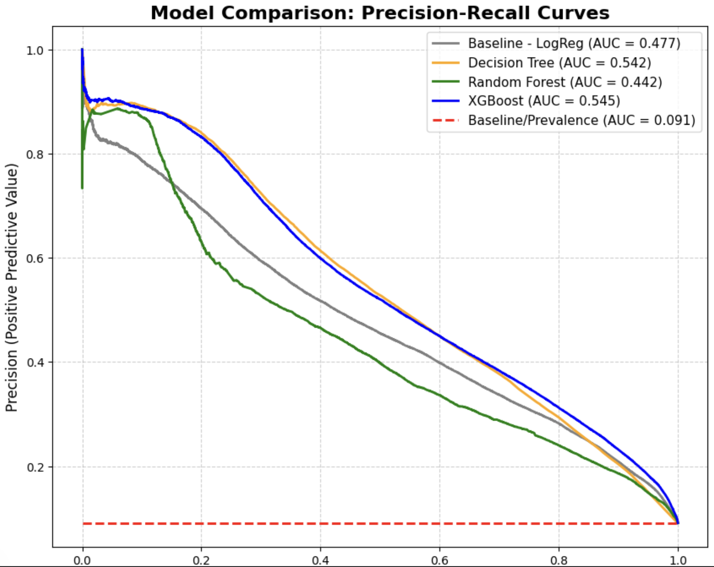

Key Findings and Recommendations

Use the below Charts to summarize the key findings and recommendations.
Seasonality:
